# Objective

The purpose of Part I of this experiment is to investigate the generation of whistle tones by side-branch ducts. As side-branch ducts are highly prevalent in applications, particularly engine intakes and exhausts, understanding the mechanism behind side-branch generated tones is of particular importance. To do this, acoustic data will be taken downstream of a main duct which has a variable length side-branch attached to it. By varying the main flow Mach number and the side-branch length, the relationship between the flow rate and side-branch length and the frequency and amplitude of the generated whistle tones. Results from this experiment will then be compared against those derived by a theoretical analysis of the problem.

The purpose of Part II of this experiment is to investigate the generation of broadband noise due to flow path modifications. To do this, two attachments will be connected to the end of a flow bench. One attachment will be comprised of a single straight section, whereas the other will include two sharp 90° bends. Acoustic data will be acquired and compared for the two configurations at one flow rate in order to evaluate the effect of path modifications resulting in flow separation and recirculation on the broadband noise generated by the flow.

# Experimental Setup

For Part I of the experiment, a flow bench was utilized to produce airflow of varying Mach numbers through a main duct with diameter of 2 inches. A side-branch of variable length and diameter of 0.6 inches was located just upstream of the exit of the main duct. The system was run with Mach number varying from 0.1 to 0.3 and side-branch lengths of 0 (baseline), 1 and 8 inches. Acoustic data was collected by a microphone located roughly 6 inches downstream of the exit of the main duct. A spectrum analyzer was connected to the microphone and recorded the frequency content of the pressure trace measured by the microphone. Based on the temperature in the laboratory, the ambient speed of sound was estimated to be 346 m/s.

For Part II of the experiment, two attachments were affixed to the exit of the main duct from Part I. The first attachment consisted simply of a single straight section, with smaller cross sectional area than the main duct. The second attachment had the same diameter as the first, but it included to sharp 90° turn along its path. As before, a microphone was placed roughly 6 inches downstream of the exit, and a spectrum analyzer was connected to the microphone in order to record the frequency content. For this test, the side-branch length was reduced to zero, and the Mach number was held constant.

# Results

## Part I

The whistle tones in the raw data were identified as peaks in the spectra which had an amplitude of 7 dB higher than the background noise. The 1 inch side-branch and 8 inch side-branch data sets were than filtered in order to remove spurious tones. If the peak in the side-branch set matched one from the baseline set (and hence, was generated not by the side-branch but by the flow bench itself) it was removed. Though this analysis resulted in the proper identification of the most prominent peaks, in some cases the higher harmonics were not identified as they were not the requisite 7 dB above the background noise. Additionally, at least one potentially spurious peak was identified as a whistle tone.

Figure 1 shows the recorded peak frequency versus main flow Mach number and the corresponding amplitudes are shown in Table 1. From this plot it is clear that the frequencies of the generated whistle tones has little dependence on the flow Mach number, which one would expect from a quarter-wave resonator. As the Mach number is increased however, additional harmonics of the primary tone are observed in the spectra, and the tone amplitudes increased as well. A low amplitude tone was identified in the Mach 0.15 flow which did not correspond to a tone in the baseline, nor does it correspond to any other identifiable tone in the other data sets. It is likely that this tone is not directly generated by the side-branch.

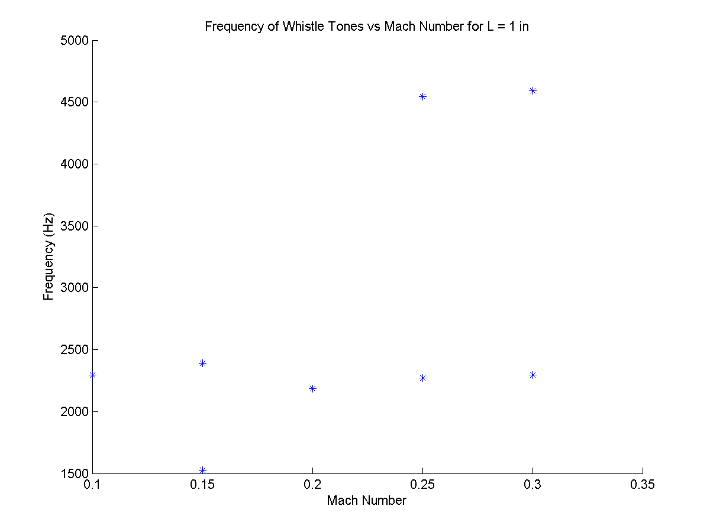

Figure : Frequency vs. Mach number for 1 in. side-branch.

Similarly, in Figure 2 the peak frequency as a function of Mach number for the 8 inch side-branch is plot. Again, the corresponding tonal amplitudes are located in Table 2. As with the 1 inch side-branch, the tone frequencies show little dependence on the flow Mach number, and increasing the Mach number results in additional observable harmonic tones and higher tone amplitudes.

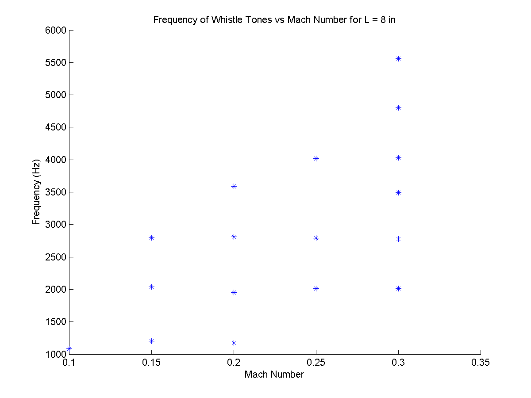

Figure : Frequency vs. Mach number for 8 in. side-branch.

Figure 3 and Figure 4 show the amplitude of each of the identified tones as a function of Strouhal number for the 1 inch and 8 inch side-branches, respectively. A negative correlation between the tone amplitude and the tone Strouhal number is clearly identifiable in the plots, meaning that the higher harmonic tones generally have lower amplitudes than the lower harmonic and the primary tones. Again, the increase in tone amplitude with increasing main flow Mach number can be clearly seen.

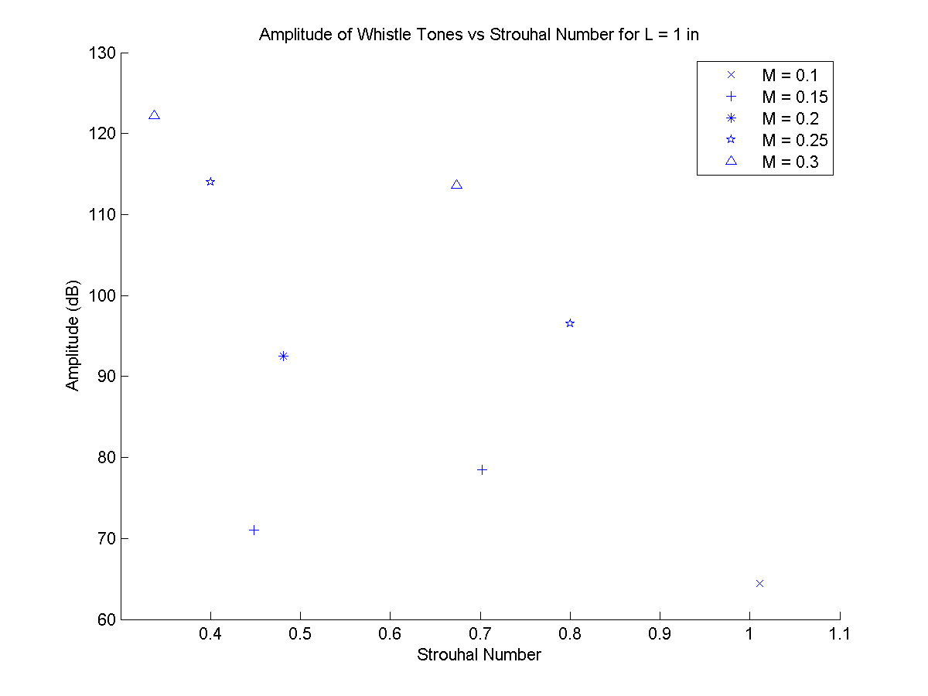

Figure : Tone sound pressure level vs. Strouhal number for 1 in. side-branch.

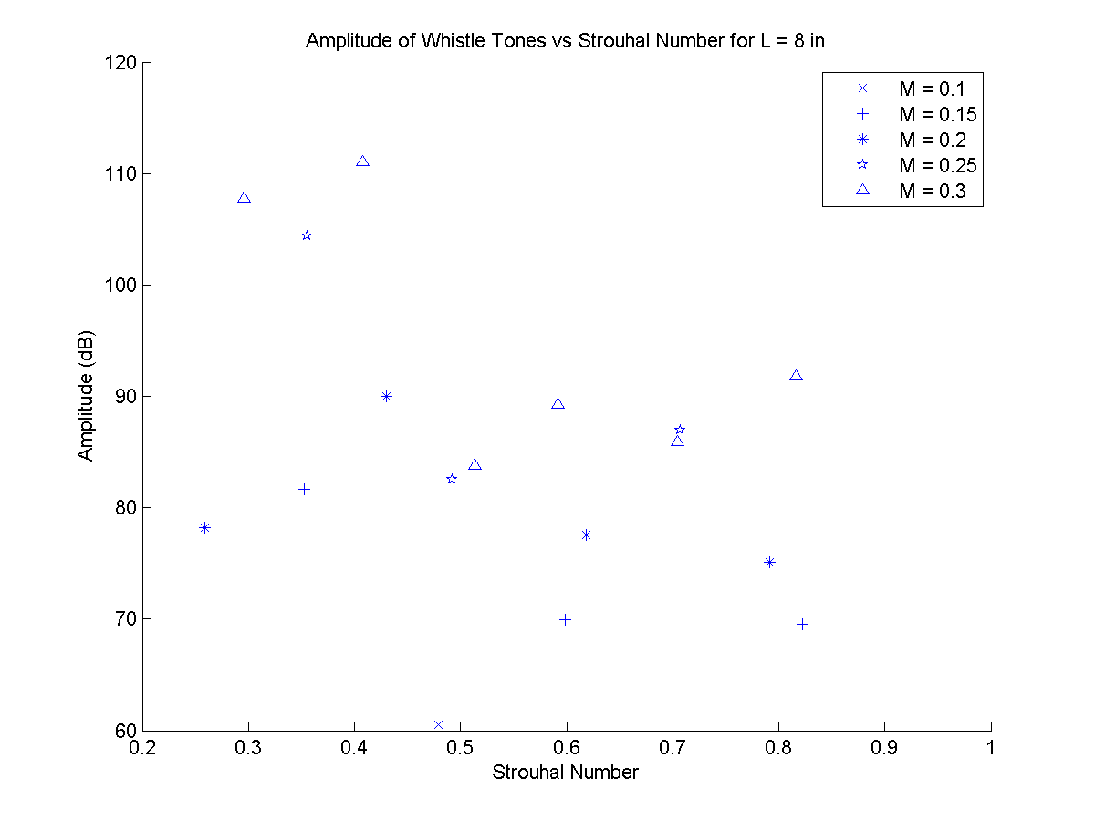

Figure : Tone sound pressure level vs. Strouhal number for 8 in. side-branch.

Table : Frequency and Amplitude of the 1 in. side-branch tones.

|  |  |  |  |
| --- | --- | --- | --- |
| Mach Number | Frequency (Hz) | Strouhal | SPL (dB) |
| 0.1 | 2296 | 1.01 | 64.49 |
| 0.15 | 1528 | 0.45 | 71 |
| 0.15 | 2392 | 0.7 | 78.47 |
| 0.2 | 2184 | 0.48 | 92.48 |
| 0.25 | 2272 | 0.4 | 114.02 |
| 0.25 | 4544 | 0.8 | 96.53 |
| 0.3 | 2296 | 0.34 | 122.18 |
| 0.3 | 4592 | 0.67 | 113.61 |

Table : Frequency and Amplitude of the 8 in. side-branch tones.

|  |  |  |  |
| --- | --- | --- | --- |
| Mach Number | Frequency (Hz) | Strouhal | SPL (dB) |
| 0.1 | 1088 | 0.48 | 60.5 |
| 0.15 | 1200 | 0.35 | 81.65 |
| 0.15 | 2040 | 0.6 | 69.96 |
| 0.15 | 2800 | 0.82 | 69.54 |
| 0.2 | 1176 | 0.26 | 78.19 |
| 0.2 | 1952 | 0.43 | 89.96 |
| 0.2 | 2808 | 0.62 | 77.52 |
| 0.2 | 3592 | 0.79 | 75.08 |
| 0.25 | 2016 | 0.36 | 104.44 |
| 0.25 | 2792 | 0.49 | 82.55 |
| 0.25 | 4016 | 0.71 | 86.98 |
| 0.3 | 2016 | 0.3 | 107.79 |
| 0.3 | 2776 | 0.41 | 111.06 |
| 0.3 | 3496 | 0.51 | 83.76 |
| 0.3 | 4032 | 0.59 | 89.23 |
| 0.3 | 4800 | 0.7 | 85.89 |
| 0.3 | 5560 | 0.82 | 91.76 |

Given as the observed whistle tone frequencies show little dependence on the main flow Mach number, as one would expect for a quarter wave resonator, an obvious avenue of investigation is to model the flow bench setup as a quarter wave resonator in order to see if the observed experimental tone frequencies match that of theory. Table 3 and Table 4 show the theoretical and experimental tone frequencies for the 1 inch and 8 inch side-branches, respectively. A very poor match is observed for the 1 inch side-branch, where the observed primary tone frequency is significantly lower than that of the expected frequencies. Additionally, the harmonic tones in the experimental data do not correspond to the second quarter wave resonance mode. This is despite the fact that the length of the side-branches used to calculate the theoretical quarter wave resonator frequency have been corrected based on the diameter of the side branch.

Table : Theoretical and Experimental Peak Frequencies for 1 in. side-branch.

|  |  |  |  |  |  |
| --- | --- | --- | --- | --- | --- |
| Theoretical | M = 0.1 | M = 0.15 | M = 0.2 | M = 0.25 | M = 0.3 |
| 2714 | 2296 | 2392 | 2184 | 2272 | 2296 |
| 8141 |  |  |  | 4544 | 4592 |

A much better match between experiment and theory is observed for the 8 inch side-branch. Though the lowest theoretical mode is not observed for any of the Mach numbers tested, the second theoretical mode corresponds well with the primary tones observed for the low Mach numbers. Additionally, the higher observed harmonic tones also agree with the theoretical frequencies, though the theory tends to over-predict the frequency slightly.

Table : Theoretical and Experimental Peak Frequencies for 8 in. side-branch.

|  |  |  |  |  |  |
| --- | --- | --- | --- | --- | --- |
| Theoretical | M = 0.1 | M = 0.15 | M = 0.2 | M = 0.25 | M = 0.3 |
| 413 |  |  |  |  |  |
| 1238 | 1088 | 1200 | 1176 |  |  |
| 2063 |  | 2040 | 1952 | 2016 | 2016 |
| 2888 |  | 2800 | 2808 | 2792 | 2776 |
| 3713 |  |  | 3592 | 4016 | 3496 |
| 4538 |  |  |  |  | 4032 |
| 5363 |  |  |  |  | 4800 |
| 6188 |  |  |  |  | 5560 |

## Part II

Figure 5 shows the measured spectra for the straight and bent ducts. The contraction from the 2 inch diameter duct to the smaller straight duct has produced periodic (in frequency) oscillations in the amplitude of the broad band noise of roughly 10 dB for both the straight and the bent duct. Oscillations at these magnitudes were not observed in the baseline duct of Part I, where the contraction was not present. The addition of the two 90° bends has resulted in an increase of roughly 40 dB of the noise throughout the entire spectrum analyzed. The cause of this broad band noise increase is likely separation and recirculation regions in the sharp 90° bends, which result in unsteady flow.

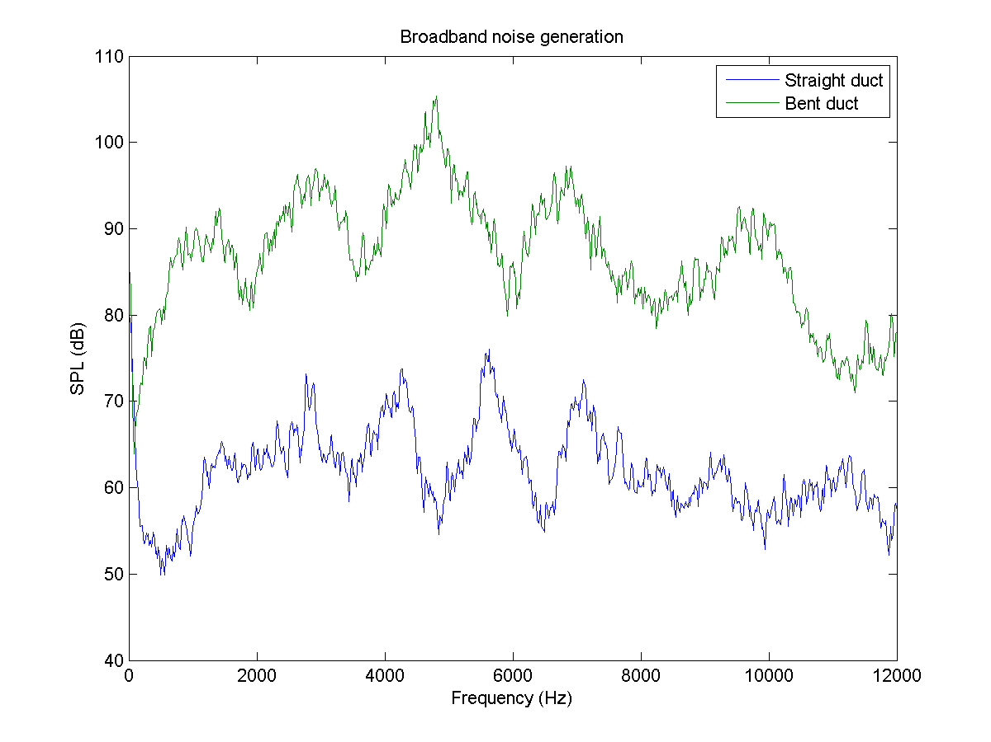

Figure : Broad band noise generation due to flow path modification.

# Conclusions

By identifying the generated tones in the spectra recorded for varying mean flow Mach number and side-branch length, it was observed that the tone frequency had a very weak, if not nonexistent, dependence on the main flow Mach number. Such results lead one to model side-branches in such configurations as quarter wave resonators, for which generated tones depend on length (and indirectly diameter) of the side-branch but not on Mach flow. Such analysis results in reasonably well agreement between the expected and observed tone frequencies for long side-branches; however for short side-branches the model does not accurately predict the tone frequencies. Unlike the tone frequencies, the amplitudes did show a strong correlation with the Mach number, as the higher Mach number sets consistently generated strong tones than the lower Mach number sets. Additionally, it was found that the lower Strouhal number tones generated the greatest amplitude tones.

The sharp 90° bends in the duct resulted in significantly higher broad band noise than the straight duct, due to the unsteady flow that is generated by the separation and recirculation regions inside the bends. Additionally, the contraction from the main duct to the exit duct resulted in oscillations in the frequency spectra for both the straight and 90° ducts.